EGERToN UNIVERSITY, NJoRo

FACULTY oF SCIENCE
DEPARTMENT oF CoMUPER SCIENCE

software design document (SDD)

for

Title: STUDENTS SYSTEMS PRoJECTS MANAGEMENT SYSTEM

prepared by: JACKLINE ACHIENG’ MBoYA
reg. no.: S13/15357/16

project supervisor: MR. KIMANI NJoRoGE
project cordinator: DR. WILFRED GIKARU

dates: 20^{TH FEBRUARY} 2020

version: 1.0

Overview
The System Design Document describes the system requirements, operating environment, system and subsystem architecture, files and database design, input formats, output layouts, human-machine interfaces, detailed design, processing logic, and external interfaces.

Table of Contents
Contents
1 INTRODUCTION 4
1.1 Purpose and Scope 4
1.2 Project Executive Summary 4
1.2.1 System Overview 4
1.2.2 Design Constraints 5
1.2.3 Future Contingencies 6
1.3 Document Organization 6
1.4 Points of Contact 6
1.5 Project References 6
1.6 Glossary 6
2 SYSTEM ARCHITECTURE 7
2.1 System Hardware Architecture 7
2.2 System Software Architecture 8
2.3 Internal Communications Architecture 11
3 FILE AND DATABASE DESIGN 12
3.1 Database Management System Files 12
3.2 Non-Database Management System Files 17
4 HUMAN-MACHINE INTERFACE 18
4.1 Inputs 18
4.2 Outputs 22
4.2.1. Student outputs 23
4.2.2. Lecturer/Supervisor 23
4.2.3. Coordinator/Admin. 25
5 DETAILED DESIGN 25
5.1 Hardware Detailed Design 25
5.2 Software Detailed Design 27
5.3 Internal Communications Detailed Design 35
6 EXTERNAL INTERFACES 36
6.1 Interface Architecture 36
6.2 Interface Detailed Design 37
7 SYSTEM INTEGRITY CONTROLS 38

INTRODUCTION

Purpose and Scope
This section provides a brief description of the Systems Design Document’s purpose and scope.
This software design document describes the architecture and system design of the Students Systems Projects Management System. This document is an overview of the dependencies and implementation of the system. It describes the design of the proposed system. This document can be used by the users of the system, system administrators, reviewers and any other user/person interested in the functioning of the system.
The system scope includes the following:

- Students uploading documents to the Coordinator.
- Approval of Project Titles.
- Students uploading of other documents (proposal, SRS and SDD among others) to both Supervisor and Coordinator.
- Tracking of individual student’s progress by Supervisor.
- Tracking Group Students Progress by CD and Coordinator.
- Continuous grading by Coordinator and Supervisor.
- Attendance tracking by Supervisor, Coordinator and CoD.
- Project grading by at least two examiners who may NOT be the supervisor of the student.
- Project final scoring by Coordinator.

Project Executive Summary
This section provides a description of the project from a management perspective and an overview of the framework within which the conceptual system design was prepared.

System Overview
This section describes the system in narrative form using non-technical terms. It should provide a high-level system architecture diagram showing a subsystem breakout of the system, if applicable. The high-level system architecture or subsystem diagrams should, if applicable, show interfaces to external systems. Supply a high-level context diagram for the system and subsystems, if applicable. Refer to the requirements trace ability matrix (RTM) in the System Requirements Specification (SRS) Document, to identify the allocation of the functional requirements into this design document.

Every year in an institute students do take projects and they send documents to the staff in charge who then store them in specific location maybe library. This leads to many hard copy files in the libraries. Some documents may end up missing leading to some technicality like student not graduating due to the lecturer couldn’t find the document to key in the results. With the help of SSPMS, the lecturer will be able to store the documents for every project the student has ever done throughout the course. The system will ensure that all information is maintained in normalized database instead of manual records. Apart from keeping the records of the projects, during the period of taking the project course, the proposed system will automate the project process enabling the student to work within the project schedule. It will ensure good planning and forecasting activities.
The proposed system will also automate processes like project documents submission, coordination and supervision of the project work. The system will improve the management of the project course in an institution. The system will create an interactive platform for students and lecturers.

Design Constraints

- The only language to be used will be English, multiple languages are not supported.
- The implementation of the database will be using the client server architecture.
- The administrator is the only one who can control the addition of other primary users in the system.
The system design proposed in this document may not capture the exact user requirements for this kind of applications. This is because of time and financial constraints. There was no enough time to collect functional requirements from the field and write user stories and iteratively and incrementally build prototypes to capture all the requirements as required in modern day user-oriented software design.

Future Contingencies
The system will allow future modifications. In future, if any changes to the system are required they can be done easily without changing the overall design.

Document Organization

This document will first describe the general organization of the system then get deeper into the internal organization of the system.
The remainder of this document identifies the references, glossary, design considerations, data design with class and table structures, system architecture with components and user interface designs. Apart from these main parts, it also states and describes the tools that will be used during implementation of this system

Points of Contact

The point of the contact of the system will be the students and lecturers who will be the users of the system.

Project References
As of the present moment, this particular kind of system doesn’t exist in most institutions thus this project will be the first project to be developed, designed and tested.

Glossary

- API – Application Programming Interface
- HTML – HyperText Markup Language
- CSS – Cascading Style Sheets
- PHP – HyperText Preprocessor
- HTTP – HyperText Transfer Protocol
- SQL – Structured Query Language
- UML – Unified Modeling Language.
- Unique Key – Used to differentiate entries in database.

SYSTEM ARCHITECTURE
In this section, describe the system and/or subsystem(s) architecture for the project. References to external entities should be minimal, as they will be described in detail in Section 6, External Interfaces.

System Hardware Architecture
In this section, describe the overall system hardware and organization. Include a list of hardware components (with a brief description of each item) and diagrams showing the connectivity between the components. If appropriate, use subsections to address each subsystem.
The system is housed in a server which comprises of a central processing unit, main memory and secondary memory as its main components. Each of these components has a specification that will suit the needs of the system. The server communicates with a MySQL database server that is used to store the information of the system.
The server is connected to the internet where the system can be interacted with through a user interface that can be accessed from a web browser by entering the respective URL.

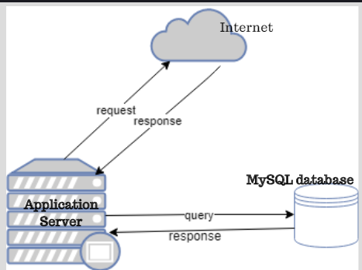

System Software Architecture
The Students Systems Projects Management System is divided into two major components: a client-side application and server side application which interacts with MySQL database.
The client-side application runs on the user’s browser and is responsible for presenting user interface that the user interacts with. The client-side application also consists of a functional component that fetches data from the back-end server to client application. The client-side validation logic will also be implemented in this part of the system. The server-side component is responsible for processing user requests and generating appropriate responses. It also interacts with the database server for data persistence.
The following tools will be used during the implementation process.
- Web browser, for example Chrome, Mozilla Firefox, Opera browser or any other according to the user’s preferences.
- Sublime Text – this will be the text editor that will be used to develop the system.
- MySQL – It is a DBMS (Database Management Server) that is used to manage the database files involved in the systems allowing data storage and access.
- Apache2 server – It is an application server from Apache Software Foundation that executes PHP scripts and renders web pages upon users’ request.

The following major languages will be used during development.
- HTML and CSS
- Bootstrap for building a responsive system.
- JavaScript for adding interactivity to the user interface.
- PHP for building the backend functionality
- MySQL for querying a database.

Admin/coordinator Use case diagram.
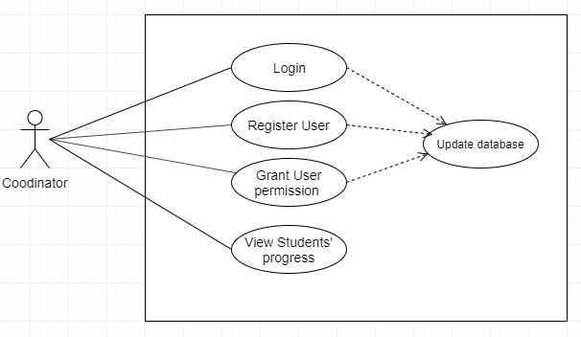

Student Use case diagram.
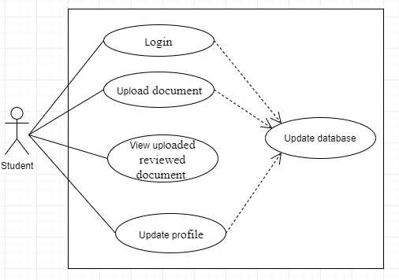

Supervisor Use case diagram.
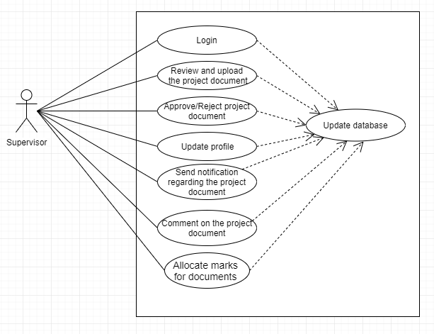

Internal Communications Architecture

The HTTP protocol will be used to facilitate proper communication between the client and server. The communication process of the system will be achieved via internet availability that will enable communication between various modules of the system. Web browsers like Google Chrome and Mozilla Firefox will be used as an interface to make the request to the web server and also to render the response back to the user of the requested resources.

FILE AND DATABASE DESIGN
Interact with the Database Administrator (DBA) when preparing this section. The section should reveal the final design of all database management system (DBMS) files and the non-DBMS files associated with the system under development. Additional information may add as required for the particular project. Provide a comprehensive data dictionary showing data element name, type, length, source, validation rules, maintenance (create, read, update, delete (CRUD) capability), data stores, outputs, aliases, and description. Can be included as an appendix.

Database Management System Files
This section reveals the final design of the DBMS files and includes the following information, as appropriate (refer to the data dictionary):

- Refined logical model; provide normalized table layouts, entity relationship diagrams, and other logical design information
- A physical description of the DBMS schemas, sub-schemas, records, sets, tables, storage page sizes, etc.
- Access methods (such as indexed, via set, sequential, random access, sorted pointer array, etc.)
- Estimate of the DBMS file size or volume of data within the file, and data pages, including overhead resulting from access methods and free space
- Definition of the update frequency of the database tables, views, files, areas, records, sets, and data pages; estimate the number of transactions if the database is an online transaction-based system.

Table 1: User table details

Columns | Constraint | Data Type | Size | Description
Id | Primary Key | Integer | 11 | Uniquely identify the user.
FirstName |  | String | 50 | Describes the first name of the user.
LastName |  | String | 50 | Describes the last name of the user.
EmailAddress |  | String | 50 | The email address of the user.
Password |  | String | 50 | The password of the user.

Table 2: Administrator table details
Columns | Constraint | Data Type | Size | Description
Id | Primary Key | Integer | 11 | Uniquely identify the admin of the system
EmailAddress |  | String | 50 | Email address of admin
Password |  | String | 50 | Password of admin

Table 1: Administrator table details
Columns | Constraint | Data Type | Size | Description
Id | Primary Key | Integer | 11 | Uniquely identify the admin of the system
EmailAddress |  | String | 50 | Email address of admin
Password |  | String | 50 | Password of admin

Table 3: Student table details

Columns | Constraint | Data Type | Size | Description
StudentRegNo | Primary Key | String | 50 | It indicates the registration number of the student.
StudentName |  | String | 50 | The student’s name
ProjectTitle | Unique | String | 100 | The project title the student is taking
LecturerId | Foreign Key | String | 50 | The lecturer (supervisor) staff ID
EmailAddress |  | String | 50 | The student email address
Password |  | String | 50 | The password of the student

Table 4: Lecturer table details

Columns | Constraint | Data Type | Size | Description
LecturerId | Primary Key | Integer | 11 | Uniquely identify the lecturer/supervisor
LecturerName |  | String | 50 | The lecturer’s name
StudentRegNo | Foreign Key | String | 50 | The student registration number.
StudentName |  | String | 50 | The student name
ProjectTitle | Unique | String | 100 | The project title the student is taking
EmailAddress |  | String | 50 | Lecturer’s email address
Password |  | String | 50 | The password of the lecturer.

Table 5: Document table details
Columns | Constraint | Data Type | Size | Description
DocumentName | Primary Key | String | 100 | Uniquely identify the name of the document being uploaded.
StudentRegNo | Foreign Key | String | 50 | The student registration number uploading the document.
StudentName |  | String | 50 | The student name to identify who is uploading and sending the document.
LecturerName |  | String | 50 | The lecturer (supervisor) name.

Table 5: Project table details
Columns | Constraint | Data Type | Size | Description
ProjectId | Primary Key | Integer | 11 | Uniquely identify project the student is be taking.
ProjectTitle | Unique | String | 100 | It is the title the student is taking it must be different from other student’s project.
StudentRegNo | Foreign Key | String | 50 | The student registration number taking the project.
StudentName |  | String | 50 | The student name taking the project.

Table 5: Document table details
Columns | Constraint | Data Type | Size | Description
DocumentName | Primary Key | String | 100 | It identifies the document (Proposal, SRS, SDD, etc.) the student is uploading and sending.
StudentRegNo | Foreign Key | String | 50 | It references the student registration number given.
StudentName |  | String | 50 | It references the student name.
LecturerName |  | String | 50 | It references the lecturer’s name.

The entity relationship diagram.

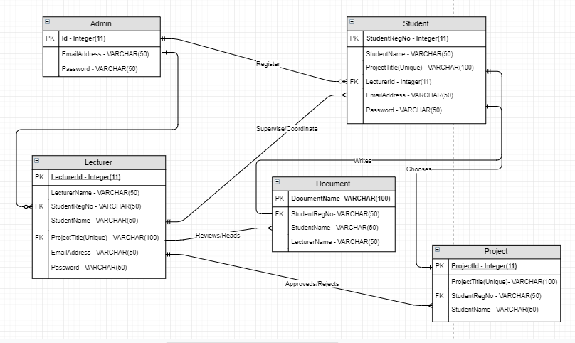

Non-Database Management System Files
In this section, provide the detailed description of all non-DBMS files and include a narrative description of the usage of each file—including if the file is used for input, output, or both; if this file is a temporary file; an indication of which modules read and write the file, etc.; and file structures (refer to the data dictionary). As appropriate, the file structure information should:

- Identify record structures, record keys or indexes, and reference data elements within the records
- Define record length (fixed or maximum variable length) and blocking factors
- Define file access method—for example, index sequential, virtual sequential, random access, etc.
- Estimate the file size or volume of data within the file, including overhead resulting from file access methods
- Define the update frequency of the file; if the file is part of an online transaction-based system, provide the estimated number of transactions per unit time, and the statistical mean, mode, and distribution of those transactions
- PHP files – will contain all the PHP files and will be used for displaying the output and formatting.
- CSS – will contain all the CSS files.
- Includes – will contain the HTML include files.
- JS – will contain all the JavaScript files.
- Documents (word documents).
- Mail files.
- Images – will contain all the website image files.

HUMAN-MACHINE INTERFACE
This section provides the detailed design of the system and subsystem inputs and outputs relative to the user/operator. Any additional information may be added to this section and may be organized according to whatever structure best presents the operator input and output designs. Depending on the particular nature of the project, it may be appropriate to repeat these sections at both the subsystem and design module levels. Additional information may be added to the subsections if the suggested lists are inadequate to describe the project inputs and outputs.

Inputs
This section is a description of the input media used by the operator for providing information to the system; show a mapping to the high-level data flows described in Section 1 .2.1, System Overview. For example, data entry screens, optical character readers, bar scanners, etc. If appropriate, the input record types, file structures, and database structures provided in Section 3, File and Database Design, may be referenced. Include data element definitions, or refer to the data dictionary.
Provide the layout of all input data screens or graphical user interfaces (GUIs) (for example, windows). Provide a graphic representation of each interface. Define all data elements associated with each screen or GUI, or reference the data dictionary.
This section should contain edit criteria for the data elements, including specific values, range of values, mandatory/optional, alphanumeric values, and length. Also address data entry controls to prevent edit bypassing.
Discuss the miscellaneous messages associated with operator inputs, including the following:
- Copies of form(s) if the input data are keyed or scanned for data entry from printed forms
- Description of any access restrictions or security considerations
- Each transaction name, code, and definition, if the system is a transaction-based processing system

Admin Sign In
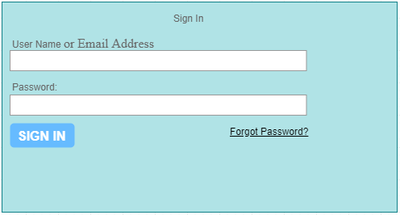

Student Sign In Form
Lecturer Sign In Form

Student Sign Up Form

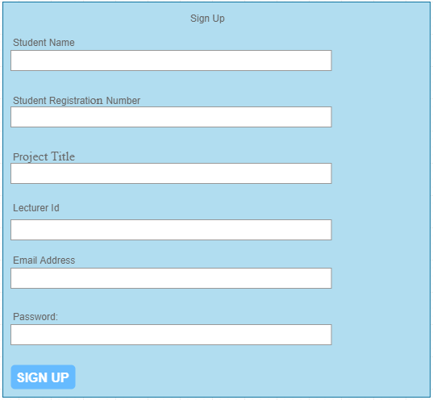

Lecturer Sign Up Form
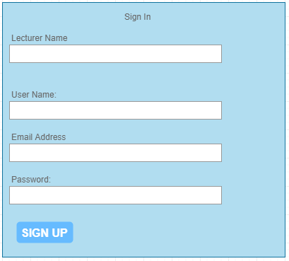

Outputs
This section describes of the system output design relative to the user/operator; show a mapping to the high-level data flows described in Section 1.2.1. System outputs include reports, data display screens and GUIs, query results, etc. The output files are described in Section 3 and may be referenced in this section. The following should be provided, if appropriate:

- Identification of codes and names for reports and data display screens
- Description of report and screen contents (provide a graphic representation of each layout and define all data elements associated with the layout or reference the data dictionary)
- Description of the purpose of the output, including identification of the primary users
- Report distribution requirements, if any (include frequency for periodic reports)
- Description of any access restrictions or security considerations
This section describes the output relative to the user of the system or the system’s operator.

4.2.1. Student outputs
Profile
The student can update his or her profile details. This details include profile image, changing password and creating a user name.

Project details

This will allow the student to add project details like project name and specify if it a software-related project or hardware-related project. The project date session will also be captured here.

Project Document

This is the part where the used will use to upload documents for review. It will contain a dropdown list of project journal, proposal, Software Requirement Specification (SRS), Software Design Document (SDD), Test plan and user manual.

System Implementation (Code)

This will include the software codes which will be inform of zipped files.

Log out

The student will use this link to sign out of the system.

4.2.2. Lecturer/Supervisor
Profile

The supervisor will be able to update his or her profile details like profile image, changing password and creating a username.

View Students

This will show a list of students (which will be in form of a table) the lecturer will be supervising.

Student Progress

This will contain all the project documents, proposal, SRS, SDD and project journal will appear here. The uploaded documents for review will be stored here. The documents will be stored as their category, for example, the proposal will be stored under proposal document, etc.

Download Document
This is where the uploaded file for review will be stored for the supervisor to access the document.

Upload Document
This will also contain a dropdown list of document. The lecturer will use it to upload documents he or she has reviewed and send the document to the respective student along with a comment/suggestion about the document. During uploading the lecturer will check if the student should revise the document or proceed to the next phase (document) of the project.

Allocate Marks

This part will contain a dropdown list for ever document which the supervisor will allocate the marks for each student according to the degree of the document.

Log out

The lecturer will use this link to sign out of the system.

Coordinator/Admin.
Profile
The admin can update his or her profile details like uploading profile image, changing password.

Register User

The administrator of the system will be able to register the system users (students and supervisors). He will be able to authenticate users of the system and assign role every user.

View Students’ Progress

The coordinator will be able to see the first version of each document and their final version only.

DETAILED DESIGN
This section provides the information needed for a system development team to actually build and integrate the hardware components, code and integrate the software modules, and interconnect the hardware and software segments into a functional product. Additionally, this section addresses the detailed procedures for combining separate COTS packages into a single system. Every detailed requirement should map back to the SRS, and the mapping should be presented in an update to the RTM and include the RTM as an appendix to this design document.

Hardware Detailed Design
A hardware component is the lowest level of design granularity in the system. Depending on the design requirements, there may be one or more components per system. This section should provide enough detailed information about individual component requirements to correctly build and/or procure all the hardware for the system (or integrate COTS items).

If there are many components or if the component documentation is extensive, place it in an appendix or reference a separate document. Add additional diagrams and information, if necessary, to describe each component and its functions, adequately. Industry-standard component specification practices should be followed. For COTS procurements, if a specific vendor has been identified, include appropriate item names. Include the following information in the detailed component designs (as applicable):

- Power input requirements for each component
- Signal impedances and logic states
- Connector specifications (serial/parallel, 11-pin, male/female, etc.)
- Memory and/or storage space requirements
- Processor requirements (speed and functionality)
- Graphical representation depicting the number of hardware items (for example, monitors, printers, servers, I/O devices), and the relative positioning of the components to each other
- Cable type(s) and length(s)
- User interfaces (buttons, toggle switches, etc.)
- Hard drive/floppy drive/CD-ROM requirements
- Monitor resolution

In order to run this system being developed, the required hardware components will include the web server with the requirements as specified in the system requirements specification document for Students Systems Projects Management System. The web server should have the recommended database management system installed to run appropriately during deployment and use by the clients. The database management system should also run on a database server running on different machines and OSs. Other hardware components include the network switch, routers, PC or digital devices that have web browsers installed in them. Internet will also be needed to allow browsing.


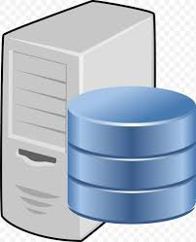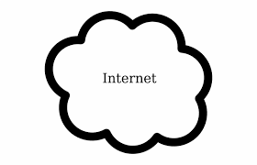


Software Detailed Design
A software module is the lowest level of design granularity in the system. Depending on the software development approach, there may be one or more modules per system. This section should provide enough detailed information about logic and data necessary to completely write source code for all modules in the system (and/or integrate COTS software programs).

If there are many modules or if the module documentation is extensive, place it in an appendix or reference a separate document. Add additional diagrams and information, if necessary, to describe each module, its functionality, and its hierarchy. Industry-standard module specification practices should be followed. Include the following information in the detailed module designs:

- A narrative description of each module, its function(s), the conditions under which it is used (called or scheduled for execution), its overall processing, logic, interfaces to other modules, interfaces to external systems, security requirements, etc.; explain any algorithms used by the module in detail
- For COTS packages, specify any call routines or bridging programs to integrate the package with the system and/or other COTS packages (for example, Dynamic Link Libraries)
- Data elements, record structures, and file structures associated with module input and output
- Graphical representation of the module processing, logic, flow of control, and algorithms, using an accepted diagramming approach (for example, structure charts, action diagrams, flowcharts, etc.)
- Data entry and data output graphics; define or reference associated data elements; if the project is large and complex or if the detailed module designs will be incorporated into a separate document, then it may be appropriate to repeat the screen information in this section
- Report layout

Class diagram
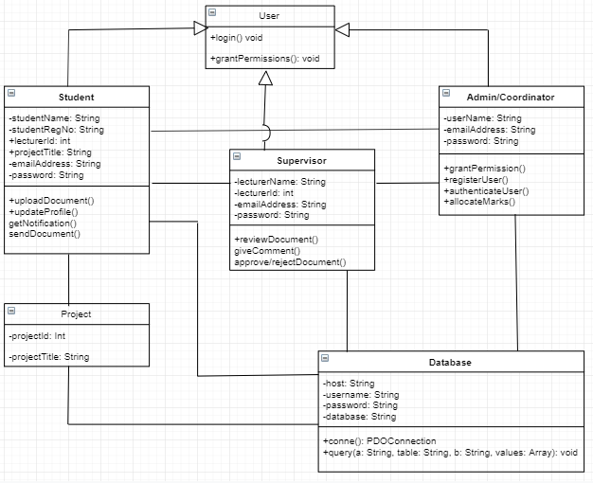

Flowchart Diagram

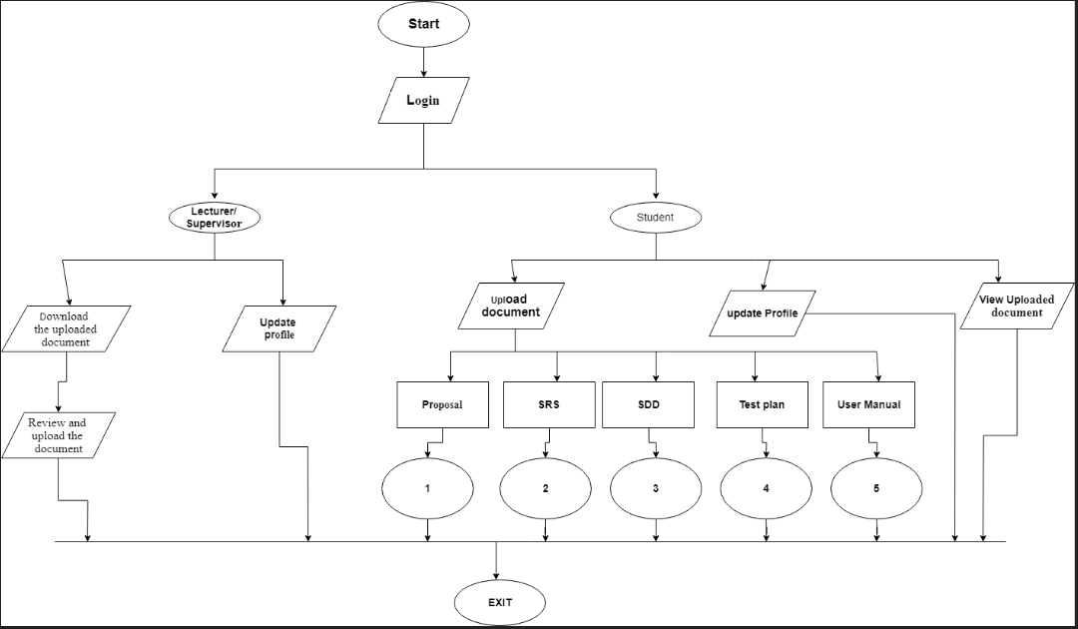

Proposal Document flow diagram
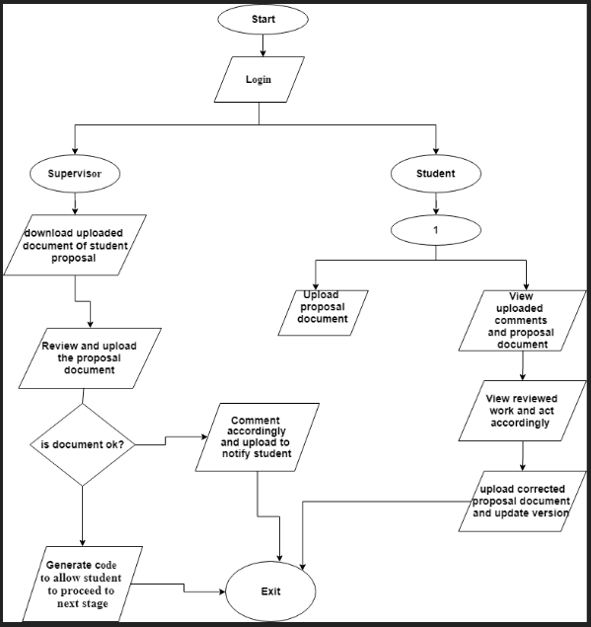

SRS document flow diagram

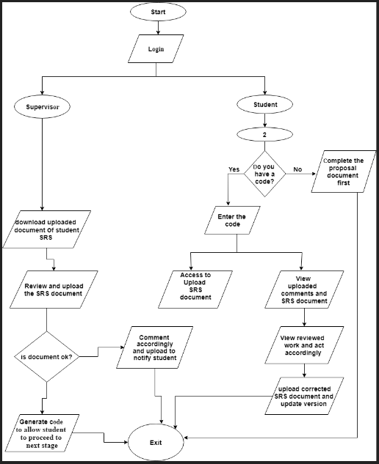

SDD document flow diagram

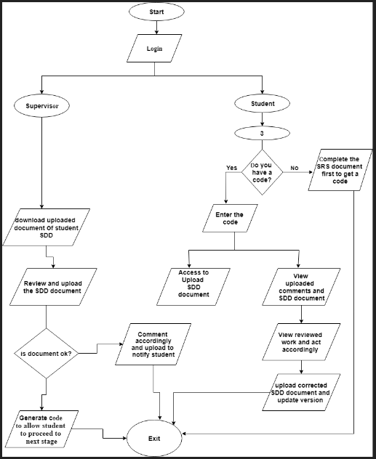

Test Plan
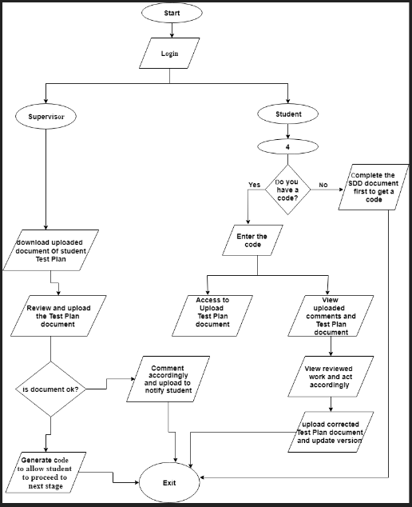

User Manual.
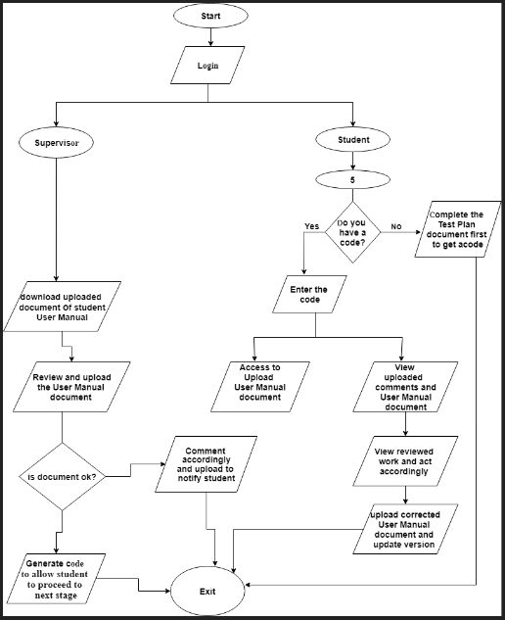

Internal Communications Detailed Design
If the system includes more than one component there may be a requirement for internal communications to exchange information, provide commands, or support input/output functions. This section should provide enough detailed information about the communication requirements to correctly build and/or procure the communications components for the system. Include the following information in the detailed designs (as appropriate):

- The number of servers and clients to be included on each area network
- Specifications for bus timing requirements and bus control
- Format(s) for data being exchanged between components
- Graphical representation of the connectivity between components, showing the direction of data flow (if applicable), and approximate distances between components; information should provide enough detail to support the procurement of hardware to complete the installation at a given location
- LAN topology
The overall communication within the system will be described in this section. The system modules will be communicating internally, fetching information from the database and displaying it for easy retrieval by the user. MySQL database will be used to make the operations easy. The communication will not require complex architecture.
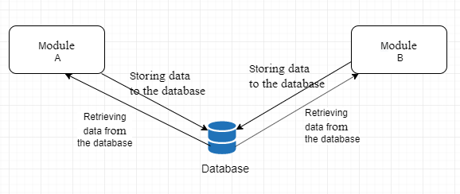

EXTERNAL INTERFACES

Interface Architecture
In this section, describe the interface(s) between the system being developed and other systems; for example, batch transfers, queries, etc. Include the interface architecture(s) being implemented, such as wide area networks, gateways, etc. Provide a diagram depicting the communications path(s) between this system and each of the other systems, which should map to the context diagrams in Section 1.2.1. If appropriate, use subsections to address each interface being implemented.
This section describes the interfaces already in place that will communicate with the SSPMS being developed. The SSPMS system to be developed will not communicate with any other external system(s).

Interface Detailed Design
For each system that provides information exchange with the system under development, there is a requirement for rules governing the interface. This section should provide enough detailed information about the interface requirements to correctly format, transmit, and/or receive data across the interface. Include the following information in the detailed design for each interface (as appropriate):

- The data format requirements; if there is a need to reformat data before they are transmitted or after incoming data is received, tools and/or methods for the reformat process should be defined
- Specifications for hand-shaking protocols between the two systems; include the content and format of the information to be included in the hand-shake messages, the timing for exchanging these messages, and the steps to be taken when errors are identified
- Format(s) for error reports exchanged between the systems; should address the disposition of error reports; for example, retained in a file, sent to a printer, flag/alarm sent to the operator, etc.
- Graphical representation of the connectivity between systems, showing the direction of data flow
- Query and response descriptions

If a formal Interface Control Document (ICD) exists for a given interface, the information can be copied, or the ICD can be referenced in this section.

The system does not integrate with any other external systems or interfaces as it will be a stand-alone system therefore this section for interface detailed design for this system will have no description of external interface.

SYSTEM INTEGRITY CONTROLS
Sensitive systems use information for which the loss, misuse, modification of, or unauthorized access to that information could affect the conduct of State programs, or the privacy to which individuals are entitled.

Developers of sensitive State systems are required to develop specifications for the following minimum levels of control:

- Internal security to restrict access of critical data items to only those access types required by users
- Audit procedures to meet control, reporting, and retention period requirements for operational and management reports
- Application audit trails to dynamically audit retrieval access to designated critical data
- Standard Tables to be used or requested for validating data fields
- Verification processes for additions, deletions, or updates of critical data
Ability to identify all audit information by user identification, network terminal identification, date, time, and data accessed or changed.

The proposed system will implement data encryption before any piece of critical and confidential information or data is stored in the database to ensure a strong system base security. Successful protection of data will ultimately ensure integrity of the system. Thus integrity checks need to be employed in order to ensure correctness of stored data and accountability for every system user. The following security controls will be implemented to ensure integrity of the system:
- Authenticity control. This will verify user’s credentials at the time of login into the system. This ensures that only authorized users are allowed to access the system.
- Integrity control. This ensures that data stored in the database cannot be violated or altered by any unauthorized users.
- Confidentiality control. This security measure prevents unauthorized access to user’s personal information.
- Authorization control. This ensures that users can only access data that they are allowed to (have permission to access).
- Client and server-side validation. This will ensure that no wrong inputs are accepted into the system.
- Security measures have been placed to prevent attacks or insecurity such as Cross Site Scripting attacks.

